Bild:

**Location:** *DE*

**Photo** Foto**:** *Sandra Hartl*

**Editor** Autor**:** *Sandra Hartl*

**Date** Datum**:** *11/2024*

**A Decade of Knowledge and Values: The SENNEBOGEN Academy Celebrates its 10th Anniversary**

In October 2024, the SENNEBOGEN Academy celebrated a special anniversary: for ten years, the training center of the traditional family-owned company SENNEBOGEN in Straubing has been providing a comprehensive educational and qualification platform for employees, customers, and partners. Since opening its doors in 2014, the Academy has evolved into much more than just a training facility. As a place of knowledge and values, it shapes the company in the three pillars of professional development, technical training, and brand development, becoming a key element of the SENNEBOGEN DNA.

**Experience Knowledge and Values – The Erich Sennebogen Museum**

A central aspect of brand development is the Erich Sennebogen Museum, based on the original plans and drawings of the company's founder. This museum brings the history and values of SENNEBOGEN to life for customers, employees, and interested visitors, acting as a unique brand ambassador for the SENNEBOGEN philosophy of "Quality and Durability Made in Germany." The exhibition allows visitors to immerse themselves deeply in the company's development and values, creating a personal connection to the brand.

**Shaping the Future Through Education and Training**

The "professional development" pillar has always focused on securing and developing skilled workers. A key area of emphasis is practical training programs for various target groups. This is complemented by seminars on personal development and leadership skills, covering topics such as rhetoric, self- and time management, and project management. A new, multi-stage, customized development program for junior leaders and high-potential employees was introduced in 2024. "This program is an example of how we foster talent and specifically prepare employees for leadership roles," explains Eva Strähuber, responsible for personnel development at SENNEBOGEN.

The "technical training" pillar is the largest area of the Academy, offering a wide range of training programs for customers, users, dealers, and employees. The offering spans from driver certifications to expert training on specific product lines and is continuously developed. Over the past ten years, around 15,000 participants have attended more than 2,000 training sessions. These figures clearly demonstrate the reach and success of the SENNEBOGEN Academy's training offerings.

**More than a Training Institution – The Academy as a Link**

Over the past ten years, the SENNEBOGEN Academy has become a place that goes far beyond the simple transfer of knowledge. "The Academy is no longer just a training facility. It connects colleagues, employees, and partners, fostering dialogue, understanding, and teamwork. It strengthens identification with our products and values, and helps employees better navigate their professional challenges, which in turn increases appreciation within the company," emphasizes Michael Ibarth, Managing Director of the Academy.

The anniversary celebration in mid-October provided the perfect occasion to reflect on the successes of the past decade and celebrate the expansion of the training offerings, the growth of the trainer team, and the introduction of new digital learning formats. Two dealers were also honored during the festivities: Schlüter Baumaschinen GmbH from Erwitte for their outstanding training participation and SMT from the Netherlands as a certified training partner. A look ahead to the future of the Academy was also given, with a focus on "Academy 2.0," which will place greater emphasis on digital solutions such as e-learning and web-based training. "The requirements for qualification are changing. In the future, skilled workers and operators will need more training in digital services – we will focus intensively on these developments," says Florian Attenhauser.

Looking ahead to the next ten years, the SENNEBOGEN Academy is firmly anchored in the company's future and in the continuous development of its employees, partners, and the SENNEBOGEN brand itself.

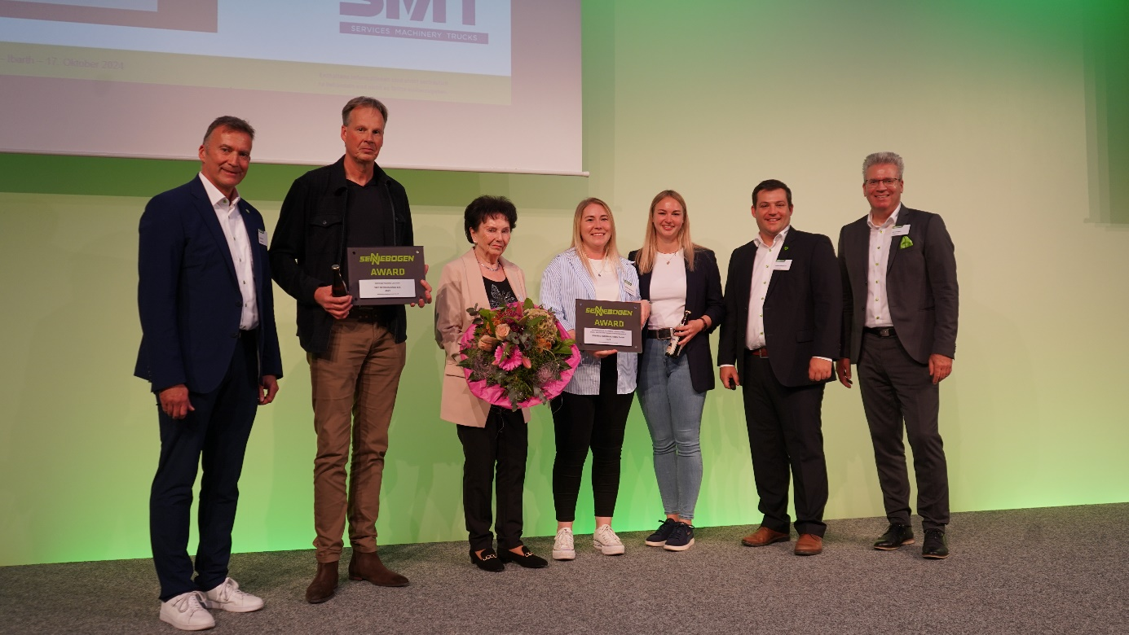

Recognition for Outstanding Achievements to Long-standing Partners: from left to right: Elmar Hurt (Managing Director of the Academy, SENNEBOGEN), Sjoerd-Anne de Vos (SMT Netherlands), Maria Sennebogen, Katharina Steltemeier, Judith Quente (both Schlüter Baumaschinen), Florian Attenhauser (Head of Training, SENNEBOGEN), Michael Ibarth (Managing Director of the Academy, SENNEBOGEN).

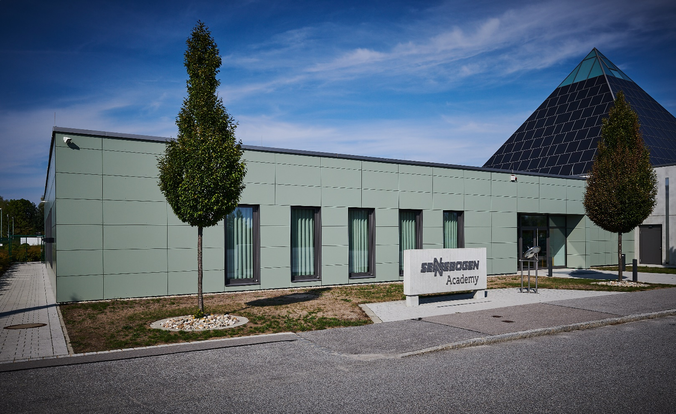

A Place for Knowledge, Exchange, and Identification for 10 Years: The SENNEBOGEN Academy Sets Standards